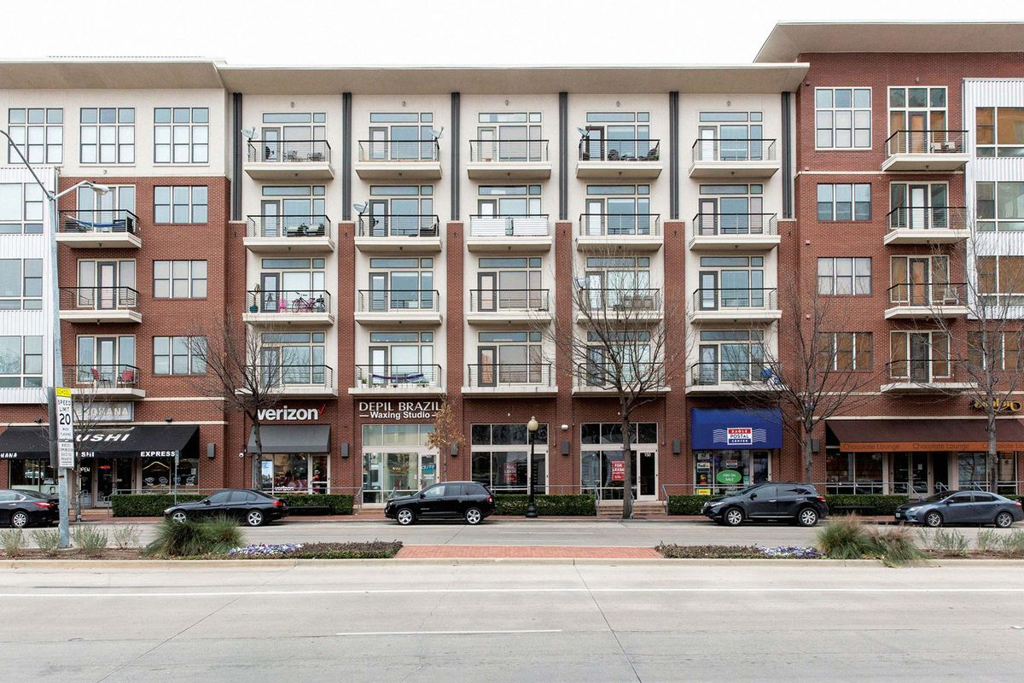
Affordable & Fair Housing

Carrboro Century Center
100 N Greensboro Street, Carrboro NC
Act now! Get your free ticket to celebrate the 29th Anniversary of the Americans with Disabilities Act at our housing and information resource fair. Festivities will include live music, food, door prizes, and a raffle. Keynote speakers are Terence Staten, Center for Homeownership, and Lauren Basil, attorney at NC Fair Housing.
We welcome Volunteers community resource agencies and individuals desiring affordable and accessible housing to attend this celebration. RAFFLE: enter last 4 digits of your phone number here __________ (keep for your records)

Saturday, July 27th
11AM-4PM

This celebration will include strategies and information in offering and obtaining accessible housing for and by people with disabilities. Invaluable information includes the following:
- Identifying and clarifying what are reasonable accommodations and specific needed modifications which are required by the current Fair Housing Laws
- Understanding the structural responsibilities and the rights of potential landlords, as stipulated in the Accessible Housing Checklist and Fair Housing Laws
- Sharing information on how housing, under the Fair Housing Laws and the ADA Title III Public Accommodations, effect landlords and their tenants
- Identifying and removing the common barriers in traditional housing designs
- Understanding and reviewing the Accessible Housing Checklist complaint process
- Providing ample opportunities for discussion and sharing of ideas and additional strategies.

This celebration is suitable for all community housing providers, realtors, insurance companies, advocates, and those seeking any information connected to housing for people with disabilities.
Don’t delay, tickets available now. Email OR Cut and mail the registration form to:
Triangle Disability Awareness Council (TDAC), PO Box 3513, Chapel Hill, NC 27516.
Any donations are welcome to cover the cost of materials, meals and facility.
Registrations must be received no later than one week (July 20th) before the event. Call (919) 245-4337 or Email any questions to Info@Triangledac.org
(Please print one form per person or providing agency)
Name: ______________________________________________________________________
Address: ____________________________________________________________________
Phone: _____________________E-mail: ___________________________________________
Community Resource Agency: ___________________________________________________
I am requesting display information: yes ___ No____ RAFFLE: write the last 4 digigts of your
phone number Here _____________
REGISTRATION

