**From Planning to Action:**

**Pilot Demonstrations Supporting Integrated, Collaborative Care for People with Intellectual and Developmental Disabilities**



**Year Two: 2018**

Abbreviated Highlights and Key Activities

December 2018

  ** **  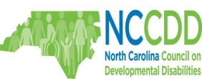

**Table of Contents**

Page

Background 3

Initiative Goals 3

Consultation Models and Demonstrations

MA Child Psychiatry Access Program 4

DUKE NC PAL: Primary Care Pediatric Telephone Consultation for

Children and Youth with Intellectual and Developmental Disability 5 - 7

Project ECHO: Extension of Community Health Outcomes 7 - 8

TEACCH UNC-CH: Increasing Access to Autism Spectrum Disorder

Specialty Care in Rural North Carolina: A Project ECHO Pilot 9 - 11

Evaluation 11 - 12

Growth Opportunities 12 – 14

Medicaid Transformation 14 – 15

Outreach and Education 15 – 16

Summary Recommendations 16

Year Three and Beyond 16 - 17

**Background**

The I/DD Medical Health Home Initiative (MHHI) is a partnership among The Arc of NC, Easter Seals UCP, and the Autism Society of NC that transitions systems-change planning groundwork into actionable demonstrations that advance innovation and access to quality healthcare for people with I/DD. Individuals with I/DD and their families want to receive healthcare from competent, caring, accessible providers. Access to a medical home is associated with increased quality of care, improved health outcomes, decreased unmet medical needs and increased satisfaction for patients and families. Some individuals with I/DD have complex care needs, such as co-occurring behavioral health diagnoses, multiple medications and chronic health conditions, and are also impacted by significant social determinants of health. Primary care providers want to be able to access professionals with I/DD expertise, so they can provide comprehensive and compassionate care for children and adults with I/DD in their practices. However, there is currently no systematic approach to accessing this I/DD consultation expertise. There is a need for a statewide consultation infrastructure and reimbursement mechanism that links healthcare providers to I/DD expertise and resources.

**Initiative Goals**

* Develop consultation services that offer a multidisciplinary team resource to improve knowledge, skills, and ability of primary care practices and providers to care for patients with I/DD in their practices
* Conduct evaluation that will enable the initiative to measure effectiveness of two demonstration consultation models for scalability and adoption by state health systems.
* Inform Medicaid Transformation, policy and practices that improve access to care and desired outcomes for individuals with I/DD and their families.

**Consultation models**

**Massachusetts Child Psychiatry Access Program (**[**MCPAP) model**](https://www.mcpap.com/Default.aspx) *www.mcpap.com*

In 2003, University of Massachusetts launched the Massachusetts Child Psychiatry Access Program (MCPAP), a program that provided telephone psychiatric consultation to pediatricians. Through MCPAP, pediatricians were given access to psychiatrists and care coordinators. Evaluation has documented that pediatricians have developed increased knowledge and comfort in treating mental health conditions, and the prescription of psychotropic medications has decreased. At start of MCPAP, 8% of pediatricians thought they could meet the psychiatric needs of their patients. After a few years 63% of those enrolled in MCPAP felt they could meet these needs. MCPAP now has 95% of pediatric providers enrolled in their services. They cover 1.5 million kids with 6 teams with funding from state Medicaid and a required per member per month contribution from commercial health plans.

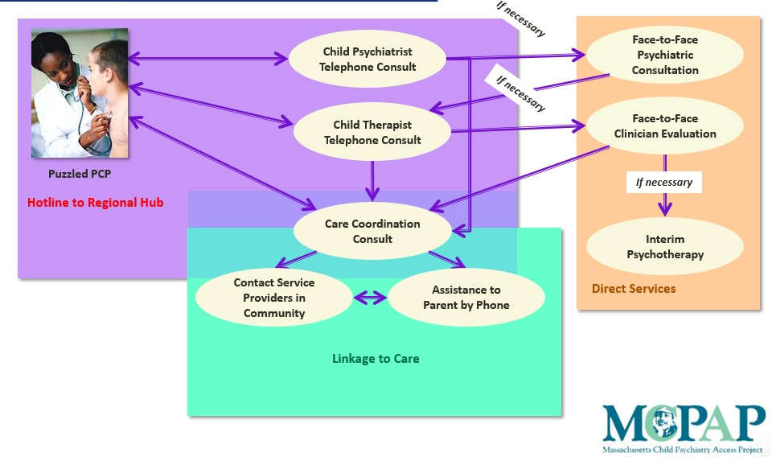

Strengths

* Utilized successfully in other states in the areas of pediatric behavioral health and pregnant mothers
* Utilization among physicians increased over time (both the volume of participants and repeat calls from individual providers). Over time two outcomes were noted: increased complexity of questions showing capacity and willingness to care for more complicated patients, and a reduction in specialty system utilization was seen as patients were increasingly served in primary care settings.
* Physician participants stated that the medical provider-to-provider consultation assists in the delivery of highly technical information quickly and made them more likely to use and trust the resource.
* The ability to support physicians and patients without opening an official medical file reduced administrative burden, duplicative files, and cost.
* Knowledge translation was most successful when “experts” answering calls had worked in and felt passionate about community-based care.

Challenges

* A focus on addressing specific questions for individual patients can have a narrow impact when compared to a group learning model like ECHO.
* Relationships with medical providers groups are critical to facilitate recruitment and participation in the program.
* Centralized support, and lack of geographic-specific resources and challenges faced by the patient or physician may limit the efficacy of information.

**Duke University: Primary Care Pediatric Telephone Consultation for Children and Youth with Intellectual and Developmental Disability**.

Primary care practices and providers have identified the need for access to colleagues with I/DD expertise to increase their competence and comfort in caring for children and adults with I/DD living in the community. NC PAL I/DD is piloting the MCPAP model with 2 practice networks: Duke’s Children’s Pediatric Primary Care that serves approximately 25,000 children primarily in Durham, Wake, and Orange counties and the UNC Complex Care Pediatric Service that serves several hundred children with complex medical needs, including many children with I/DD. The core team is Duke Integrated Pediatric Mental Health, UNC General Pediatrics, UNC Carolina Institute for DD, and NC START Central. Partners include Duke and UNC pediatric practices and providers, Alliance and Cardinal Innovations LME MCOs, Autism Society of NC, community agencies, self-advocates and families.

Duke conducted an extensive review of more than 498 charts meeting study criteria of intellectual and developmental disability diagnosis and assignment to the Durham Pediatric Clinic. Data highlights include:

* Most of the patients are between the ages of 3 and 21
* 76% have been seen at primary care practice within last 6 months
* 60% are on Medicaid
* 67% have Autism Spectrum Disorder (ASD) diagnosis
* 27 % have an intellectual disability diagnosis
* 2 of the most frequent Mental Health diagnosis are AHDH (32%) and anxiety (17%)
* 69% have never been screened for IDD service eligibility
* Only 10% are receiving Innovations Waiver services
* Only 11% are on the registry of unmet needs.

NC PAL I/DD identified the need to provide proactive outreach to many of these primary care practices and providers, and not just respond when an individual patient is in crisis or distress. To develop a robust consultative service for the I/DD population, it is necessary to have both telephone consultation to provide information to parents and providers in real time AND proactive strategies to support individuals with I/DD. including case finding and needs identification.

The NC PAL I/DD call line was launched in May 2018. Initially there were a limited number of calls, and most of the requests for consultation came through EHR (electronic health record) messaging and face to face contacts. Of note is that many of the calls focused on a need for case management, systems navigation, resource linkage and referrals. A summary of the initial reactive consultation calls is below:

* 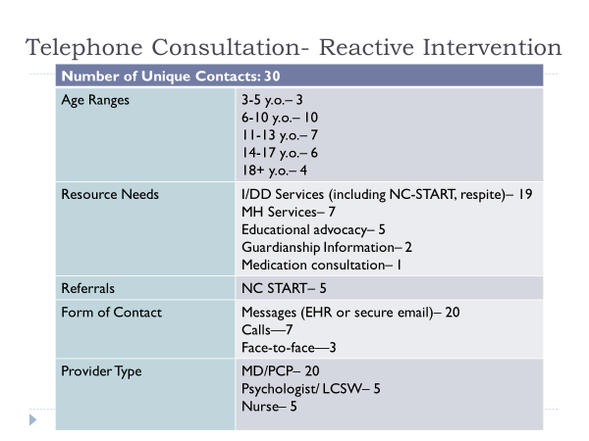

Duke NC PAL has also increased it focus on family support and the employment of a family partner (family member with experience raising a child with a disability) to provide resource help, emotional support, encouragement, and systems navigation. Common themes voiced by families are the need for respite, questions about how to apply for Innovation Waiver services, how to access Applied Behavior Analysis (ABA) services, medical insurance, educational supports, guardianship, and transition.

Duke has refined the chart review process to develop a case finding protocol that will support proactive outreach to other pediatric practices: TEACCH is piloting this protocol by abstracting data from the UNC Healthcare Carolina Data Warehouse to document ASD system utilization across the UNC Healthcare System. This data will be used in collaboration with data from Duke to better understand the health care needs of children with ASD across a wide area of North Carolina.

Next Steps:

* Explore use of the new Medicaid Behavioral Health Consultant Codes
* Develop and pilot a checklist to assess whether individual and family needs are being met
* Distribute a Resource Packet for healthcare providers
* Develop a Resource Packet for families and community providers
* Share Resource Packets with TEACCH Project ECHO
* Utilize case finding data to identify when patients with I/DD are scheduled for routine visits and offer families a pre-visit screening call
* Screen for enrollment in Innovations Waiver or the registry of unmet needs

[**Project ECHO**](https://echo.unm.edu/about-echo/model/)**: Extension of Community Health Outcomes**  *https://echo.unm.edu/*

In 2003 the University of New Mexico launched Project ECHO® (Extension for Community Healthcare Outcomes) as a way to improve access to care for patients with hepatitis C. The limited number of specialists available to treat this disease meant that patients waited months for care and traveled great distances. The goal was to enable primary care clinicians to treat hepatitis C patients in their communities by linking local providers to a team of specialists at an academic medical center. Treatment for hepatitis C is now available at centers of excellence across New Mexico. A [2011 study](http://www.nejm.org/doi/full/10.1056/NEJMoa1009370) published in the *New England Journal of Medicine*showed that the quality of hepatitis C care provided by Project ECHO-trained clinicians was equal to that of care provided by university-based specialists. Project ECHO has grown to address multiple diseases and other health conditions, such as opioids, Autism, and pain management. Today, Project ECHO operates more than 220 hubs for more than 100 diseases and conditions in 31 countries.

The goal of ECHO is to spread knowledge, expand capacity and accelerate collective wisdom. ECHO utilizes a hub and spokes model linking interdisciplinary teams of specialists (the hub) with primary care providers in multiple practice sites in the community (the spokes). The experts serve as teachers and mentors who share their expertise in a virtual learning community. The primary care provider remains responsible for the on-going care of their patient.

Core elements of the EHCO model are:

* + Use of technology to leverage scarce resources
  + Sharing “best practices” to reduce disparities
  + Case-based learning to master complexity
  + Web-based database to monitor outcomes

ECHO Virtual Clinic format:

* + Didactic presentations and discussions of evidence-based practices
  + 1-2 in-depth case discussions led by participants
  + Consultation from the experts and group discussion
  + Follow up after the initial case discussion

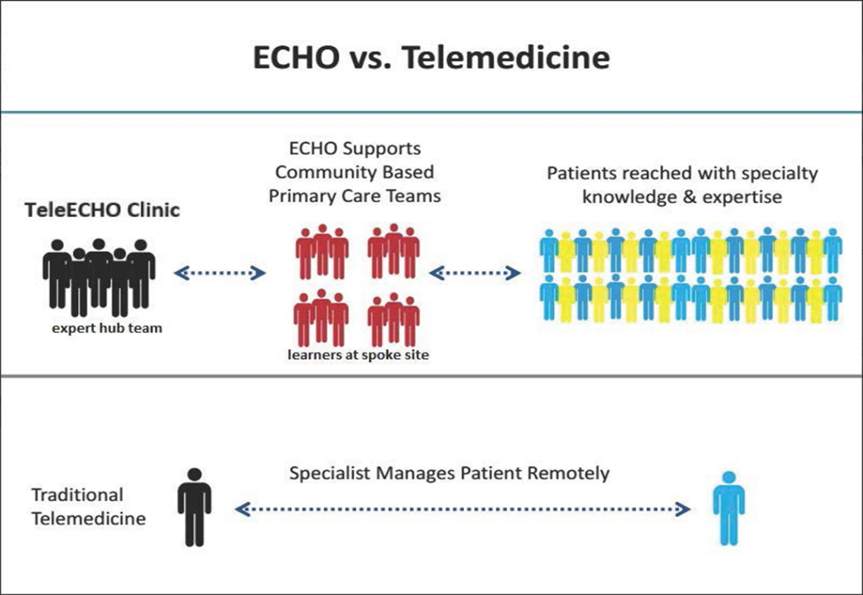

Strengths:

* Addresses the needs of rural and low resourced communities and providers
* Rapid dissemination of best practices and promising practices
* Promotes consistency of care within the medical home
* Providers can decrease their professional isolation
* Patients can access quality care in their community

Challenges:

* Not all practices or providers can commit to the learning model time
* Only a limited number of practitioners can participate at one time
* The learning model is topic specific. If a medical practitioner doesn’t already see that topic or population as a priority for their practice, they are unlikely to seek out the learning opportunity.

**TEACCH, UNC-CH: Increasing Access to Autism Spectrum Disorder Specialty Care in Rural North Carolina: A Project ECHO Pilot**. Many families are more likely to receive treatment and care from pediatricians and family medicine physicians in their communities rather than specialty providers. Families in rural communities often experience greater delays in diagnosis and referral to appropriate treatment services. This project is designed to improve the quality of lifespan care received by individuals with ASD by increasing community providers’ diagnostic screening and treatment of common medical and behavioral health comorbidities experienced by individuals with ASD. It is also intended to increase primary care providers knowledge of ASD and I/DD resources and referral processes.

This project is a partnership among the Autism Society of NC, Carolina Institute on Developmental Disabilities (CIDD) at UNC-CH, and Area Health Education Center (AHEC). The first primary care ECHO recruited 13 providers in the Rural Health Group (RHG) practice network. RHG is a non-profit, federally qualified community health center dedicated to providing primary medical care, dental care, and other health-related services in eastern North Carolina. ECHO sessions were consistently attended by the majority of the registered participants. The ECHO sessions were offered twice a month between January and July 2018.

Recruitment for cohort two was impacted by Hurricane Florence resulting and resulted in a delayed start date of January 2019. The second cohort has enrolled primary care providers from Dunn, New Bern, Wallace, Goshen, Southport, Faison, Goldsboro, and Wilmington. TEACCH completed a mental health (MH) ECHO cohort in 2018 and is at the mid-point in the second MH cohort.

TEACCH ECHO curriculum topics in the primary care cohort:

* What is Autism and While You Wait
* Autism Screening (MCHAT) and Follow-Up
* Parent Support
* What is Applied Behavior Analysis (ABA) and Structured TEACCHING Strategies
* Resources- Local, State, Regional, and National
* ADHD &Autism: Differential Diagnosis & Medication Management
* Feeding Issues and Autism
* Sleep and Autism
* Anxiety, Autism: Differential Diagnosis & Medication Management
* Behavior from the ASD Perspective- Irritability, transitions, and sensory issues
* What is an IEP?
* Transition to Adulthood

The evaluation has documented the following findings: ECHO Autism is improving the providers ability to care for individuals with ASD; MCHAT screening rates increased; participants are connecting with peers and colleagues through ECHO Autism; they have greater confidence in working with patients with ASD; providers have had the opportunity to use the ECHO information with a patient; the presentations and case based learning are enhancing their knowledge about autism; and they are satisfied with the pace of the ECHO Autism. The evaluation also identified some challenges: resources are not available in all communities; comprehensive care management combined with medication management and family support is necessary for many patients; most providers are unaware of the community and state disability and ASD-specific resources.

Participant in the primary care ECHO*: “The most valuable aspect of this project was learning about the resources available for me and my patients. I've also enjoyed how there is a team giving their unique feedback based on different roles caring for the patient. This has helped me broaden my vision of the care required for best outcomes.”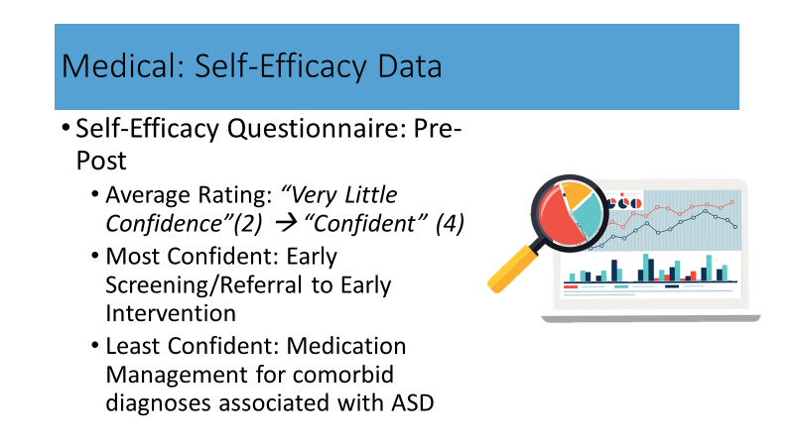*

The evaluation data offers insight into ongoing needs of primary care providers and how telephone consultation could address specific patient needs, such as medication management.

It has been easier to recruit participants for the mental health (MH) cohorts. There is some overlap with the curriculum topics. Both the primary care and MH cohorts demonstrated positive changes in knowledge about ASD and self-efficacy.

Participant in the Mental Health ECHO: *“I know I feel that I better understand the “how’s" and "whys" of the behavioral functioning of children with autism in addition to a greater level of understanding of the learning styles and how these impact the daily functioning of a person with autism. Additionally, I have gained a wealth of knowledge regarding interventions and approaches to interventions. This training is truly insightful, practical, and empowering. Hands down, this training is an effective use of time and is yielding fruitful results. I feel very fortunate to have the opportunity to participate in this training with such experts in the field!”*

The project leads attended a meeting of the national Autism ECHO collaborative that included the University of Virginia (UVA), Children’s Hospital of Philadelphia, University of Wyoming, Cincinnati Children’s Hospital, University of Iowa, University of New Mexico, University of Washington, University of Missouri, SUNY, and Autism Speaks. Discussion focused on outcomes of interest, evaluation strategies, and funding. The group plans to write a white paper on system change in disseminating evidence-based practices through adult learning principles. Of note is that the TEACCH mental heath ECHO is the first of its kind and the UVA is interested in replicating it in their state. Missouri currently receives Medicaid funding Other states are relying on grants. Dr. Sohl, with the Missouri EHCO Autism, has agreed to consult with TEACCH regarding sustainability strategies for North Carolina.

Next Steps:

* Implementation and evaluation of primary care cohort two
* Complete implementation and evaluation of Mental health cohort two
* Comparison of evaluation findings from ECHO cohorts
* Review and distribute the Resource Packet developed by NC PAL IDD
* Share results of case finding within UNC Healthcare system charts utilizing the Duke protocol
* Consult with national Autism ECHO collaborative

**Evaluation Activities to Date**

When feasible both projects are using common outcomes and measures:

* Change in primary care providers’ (PCP) understanding of I/DD system issues
* Change in PCP perceived self-efficacy
* Change in comfort in PCP with I/DD and ASD related psychopharmacology
* Change in PCP efficacy with resource finding and referral
* PCP satisfaction with the consultation program: telephone and ECHO
* Change in access to I/DD system and services, including specialists
* Family satisfaction with consultation
* Change in quality of life indicators

Following consultation with Dr. Shelia Marcus, Department of Psychiatry, Michigan Medicine and the Michigan Child Collaborative Care Program, the pilots will also ask the users of the Duke NCPAL and TEACCH ECHO services “did this service ….:

* Prevent hospitalizations
* Prevent Emergency Department Visits
* Reduce lengthy Emergency Department stays
* Medication: Now, over time, type, quantity, cost
* Change level of care

Qualitative interviews are underway to gather additional feedback about providers and families satisfaction with the service, ease of use, and impact on patient care over time.

**Preliminary Recommendations**

* Both TEACCH and Duke consultation pilots are evolving to meet North Carolina’s needs and address gaps and needs in our unique system.
* Both programs have identified the need for a consistent and comprehensive focus on care management, systems navigation and family support
* Sustainability and efficacy will require linkage between consultation, navigation, family support, and a robust care management network
* Data-supported decision making is critical on both a practice and systems level

**Growth Opportunities**

Duke is collaborating with Cardinal Innovations Local Management Entity/Managed Care Organization (LME MCO) on a two year pilot for mental health telephone consultation service for pediatric practices, based on the MCPAP model. The program targets 6 counties: Person, Vance, Warren, Halifax, Franklin and Granville.

North Carolina is one of 18 states to receive a 5 year Health Resources and Services Administration (HRSA) grant to scale the MCPAP telephone/telehealth consultation statewide to address pediatric behavioral health. The lead applicant is the NC DHHS, Division of Public Health. Partners include Duke University and Community Care of NC (CCNC). The plan is to expand the NC PAL program telephone consultation to cover 20 counties in the first year and reach statewide penetration by year five.

The state also received a second HRSA grant addressing maternal depression. The lead applicant is the NC DHHS, Division of Public Health, in partnership with UNC-CH, and Duke University. Only three states received both HRSA consultation grants. These multi-year awards provide the opportunity to expand the implementation and evaluation of telephone consultation services, address the educational needs of primary are providers, and promote the inclusion of children and adults with IDD in the target patient population.

TEACCH is developing a military community ECHO, targeting providers on base and in the surrounding areas of Camp Lejeune and Fort Bragg. Recruitment for the hub team and cohort participants is underway. This ECHO will combine medical and mental health providers and is receiving funding support from AHEC.

The NC DHHS provided funding that has supported an array of activities linked to Medicaid transformation, integrated care innovation, and meeting the needs of children with complex needs. Core activities included:

* 2018 Summit “Advancing Integration through Consultation Services in North Carolina”
* Development of a Consultation Glossary of Terms related to elements of integrated care, whole-person care, and healthcare reform
* Compilation of consultation research and best practices implemented in other stateswith a focus on policies, financing, and partnerships that promote systems change and sustainability
* Preliminary inventory of current NC consultation activities addressing behavioral health and I/DD populations
* Policy brief on diagnostic service recommendations to provide comprehensive and responsive care for children with complex care needs
* Funding and technical assistance for Mission Health Systems to develop an integrated model of developmental and behavioral pediatric care in the western region in partnership with Mission Health Partners, Olsun Huff Center, Family Support Network of Western NC, MAHEC, Vaya Health, McDowell Pediatrics, and other community partners.
* Funds to explore the feasibility of a community collaborative in the Greenville and Wilmington areas that will identify community needs, assets, subject matter experts, and organizations that can invest in the evaluation and coordination of care of children with complex needs.

Reimbursement Opportunities

The NC Medicaid Bulletin released in September 2018 includes information on reimbursement for psychiatric collaborative care management services that can promote behavioral health integration in primary care settings effective October 1, 2018. The psychiatric collaborative care management services must be rendered under the direction of a treating physician, typically in a primary care setting. These services are allowable when a beneficiary has a diagnosed psychiatric disorder AND requires assessment, care planning, and provision of brief interventions.

The codes are:

* 99492: $73.86, $130.64 (facility rate, non-facility rate), first 70 minutes per month of care management
* 99493: $66.78, $104.54 (facility rate, non-facility rate), next 60 minutes of care management per month
* 99494: $35.63, $54.08 (facility rate, non-facility rate), each additional 30 minutes of care management per month

**Medicaid Transformation**

At the request of NC DHHS, the initiative has shared recommendations and resource material with leadership staff and consultants assisting with development of the Tailored Plan. The content has focused on consultation models and NC pilots, health navigation, and key MHHI recommendations. The team continues to meet regularly with NC DHHS staff from the Divisions of MH-DD-SAS, State Operated Healthcare Facilities, and Health Benefits. The team continues to review NC DHHS concept papers and briefs and contribute to discussions at the DD Consortium.

Information Gathering

The project director has been in communication with national subject matter experts in Medicaid managed care and LTSS in Michigan, Massachusetts, Arizona, Tennessee, New York, and Indiana.

In March 2018 the project director facilitated a panel conversation at The Arc of NC conference with five MCOs that plan to bid on the Medicaid Transformation Standard and Tailored Plans. The session was attended by approximately 65 people, including family members and self-advocates. The initiative team has shared information on the MHHI and consultation demonstrations with several of these MCOs.

The team submitted a policy brief on the need to develop regional multi-disciplinary evaluation clinics to meet the needs of children with complex care needs. The brief was submitted to Disability Rights NC and NC DHHS.

**Outreach and Education**

The initiative has launched a website as another means of disseminating information to multiple audiences. <http://www.iddmedicalhealthhomencinitiative.com/>

In May the initiative sponsored “Advancing Integration through Consultation Services” summit that was attended by more than 65 participants representing advocates, healthcare and disability providers, LME MCOs, policy makers, and MCOs. The agenda included presentations by Duke NC PAL IDD, TEACCH Project ECHO, University of Michigan on provision of consultative services to rural communities, and Wyoming’s use of ECHO to address diverse learning needs.

2018 Presentations:

* Inaugural Campbell University Rural Oral Health Summit, February: "Promoting Oral Health for People with Intellectual and Developmental Disabilities”
* The Arc of NC pre-conference, March. “The Future of Managed Care in NC”, facilitated panel discussion with MCOs
* Money Follows the Person webinar, April. “Building the Foundation for Person-Centered Health Care and Quality of Life for People with Developmental Disabilities” sponsored by Division of Medical Assistance, Special Initiatives, NC DHHS
* NC TIDE spring conference, May. “Keeping the Person at the Center of Care and Transformation” and panel discussion with self-advocates, families and DD providers.
* Transforming Care through System Integration and Communications conference, May.

“Our Biggest Assets: informed and engaged individuals, families and providers”

* START National Training Institute, May. “Providing Integrated Health Support to Children with Intellectual/Developmental Disabilities”, with co-presenters from the Duke NC PAL IDD project
* i2i Center for Integrative Health Spring Policy Forum, June. “Embedding a Whole Person Approach into the Emerging System of I/DD Services” with co-presenter Josh Boynton
* MAHEC Peer Support conference, October. “Family Support: an overlooked asset that can promote integration and innovation in diverse healthcare settings” with co-presenter Kerri Eaker
* Supported Living Webinar, November. “Person-Centered Living & Individualized Supports: What’s the Connection?” Sponsored by Vaya Health, NC Council on Developmental Disabilities, and Money Follows the Person.

Oral Health: The NC Division of Public Health, Oral Health section was awarded a HRSA grant to support oral health workforce through innovative continuing education. The objectives include replication of the I/DD workshop piloted in 2016. An article on article on improving access to dental care people with I/DD, authored by the project director, was included in the fall 2018 Oral Health Equity newsletter.

**Summary Recommendations**

As North Carolina progresses with transformation it is critical that North Carolina implement a responsive, robust and multi-faceted approach to integrated care. This requires a commitment to multiple principles and elements:

* No single consultation model will be sufficient. The needs and resources of individuals with I/DD, families, and providers vary across the state and over time.
* Individuals with I/DD are and will be a part of every health system. While a majority of the I/DD population being served or waiting for services are slated to become part of the Tailored Plans (TP), that represents only approximately 15% of the total I/DD population in North Carolina. Therefore, case finding, consultation, education, navigation and family support must be available in both Standard Plans (SP) and Tailored Plans (TP).
* Successful navigation requires in-depth knowledge of I/DD service system, health systems, and community resources to address social determinants of health.
* Optimal health and connection to services and supports (both I/DD-specific and more general social determinants) are the building blocks to achieving maximum independence, community-based living, and meaningful employment
* Successful implementation of Medicaid Transformation requires a dynamic process: demonstration projects 🡪 implementation 🡪 evaluation 🡪 data-informed adjustments 🡪 implementation 🡪 evaluation
* Continuous efforts to identify best practices, models, strategies, and resources that promote person-centered collaborative care for people with I/DD across the life course

**Year Three (2019) and Beyond**

To ensure a continued return on the Council’s investment, it is essential that all stakeholders remain committed to ensuring that Medicaid Transformation meets the needs of children and adults with I/DD and their families. Some of the questions that need to be asked are:

Standard Plans: Many people with I/DD will be in the Standard Plans. How will we ensure that the state evaluates these members experience and satisfaction with care? Are they receiving integrated care? How is care management being provided to children and adults with I/DD? How is data on health care utilization and health outcomes being tracked, analyzed and reported? Are people with I/DD being served within advanced medical homes? How are social determinants of health being addressed? How are staff of the prepaid health plans/MCOs being trained? What training and supports do primary care providers and medical specialists need to care effectively for children and adults with I/DD? Do the innovation pilots include people with I/DD?

Tailored Plans: The above questions need to be asked when the Tailored Plans roll out. Additional questions are: how are long-term services and supports linked to the delivery of integrated care? Are individuals able to access the specialty care they need?

The NC Council on Developmental Disabilities has played a critical role in improving the opportunities and lives of North Carolinians with I/DD through advocacy, capacity building, and systems change. This leadership and investment will be essential in future years.