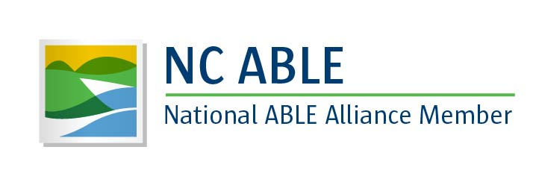

NC ABLE Accounts
Ten Important Things to Know

1 - What is a NC ABLE account and how does it help people with disabilities and their parents/guardians?

NC ABLE accounts are tax-advantaged saving and investment accounts that allow eligible individuals with disabilities the opportunity to save money without jeopardizing eligibility for means-tested programs and supports.

Individuals with disabilities sometimes must rely on federal benefits — such as Supplemental Security Income (SSI) and Medicaid — for their day-to-day living expenses, support services and healthcare costs. These benefits programs are “means-tested.” To be eligible for these benefits, savings and assets must not exceed specified limits. Most of the programs limit savings and “countable resources” to about $2,000. This significantly constrains a person’s ability to save for any unforeseen emergencies or for planned, larger expenses — even if the savings are later spent to meet disability-related expenses. Now, with a NC ABLE account, up to and including $100,000 saved is not considered part of “countable resources” when determining eligibility for most federal means-tested programs.

2 - Who is eligible to open a NC ABLE account?

Eligible individuals are those who have met the disability requirements for SSI or Social Security disability benefits (Title XVI or Title II of the Social Security Act) and are receiving those benefits OR a “medically determinable physical or mental impairment,” within the definition of the Social Security Act. And, the onset of the individual’s disability must have occurred prior to the individual’s 26th birthday. Parents of eligible children, and guardians of eligible persons, may open an account on behalf of their children or an eligible person. Individuals can self-certify that they qualify to open an NC ABLE account.

3 - Is there a Medicaid payback provision?
Yes. When the qualified beneficiary (the person who "owns" an ABLE account) dies, with remaining assets in an ABLE account, the assets in the account may be used to “pay back” any state Medicaid plan up to the value of Medicaid services provided to the beneficiary after the account was opened. The amount is calculated after 1) any outstanding qualified disability expenses are paid, 2) after any funeral and burial expenses for the qualified beneficiary are paid, and 3) any Medicaid premiums paid by the beneficiary are subtracted.

4 - What are the costs associated with a NC ABLE Account?

NC ABLE account fees are extremely competitive when compared to ABLE accounts available across the country.
Participants in NC ABLE accounts will be assessed a flat, $45 annual account maintenance fee, which covers financial recordkeeping and communications services, online account access, online quarterly statements, and toll-free customer service call center assistance. This includes a $5 annual administration fee that helps defray some of the operating expenses for the NC ABLE program, including legal, compliance and community outreach activities. These costs, a total of $45 per year for each NC ABLE account, are the same for all account holders, regardless of the balance on the account. Underlying fund fees apply for mutual fund investments within NC ABLE accounts. Please note, that for those account holders who would like to receive quarterly statements by mail, there is an additional $15 annual cost for this service. See additional information about checking and debit card options on the next page.

5 - What are the rules about saving money (“contributions”) in a NC ABLE account?

The greatest advantage of the NC ABLE account is that it offers the opportunity for individuals with disabilities to accumulate savings for qualified disability expenses, without jeopardizing eligibility for federal benefits, like Medicaid services, that many rely on for basic needs. Savings in NC ABLE accounts are not considered “countable resources” for SSI and Medicaid eligibility. With a NC ABLE account balance up to $100,000, individuals will maintain eligibility for SSI and most federal means-tested programs. NC ABLE account owners may save more than $100,000 and maintain eligibility for Medicaid. Keep in mind that beneficiaries must continue to meet income and other requirements specific to each program. In total, annual contributions to an individual’s NC ABLE account may not exceed $14,000 in a single calendar year. For those who wish to make a gift to a person with a NC ABLE account, the funds must be deposited directly into the NC ABLE account to avoid the deposit being considered income to the account holder.
6 - How many ABLE accounts are permitted?

NC ABLE accounts are available NATIONWIDE to all eligible individuals, regardless of where they live. Qualified individuals are limited to one open ABLE account, except in the case of a rollover from another qualified ABLE program. Transfers or “rollovers” are permitted for those individuals who would like to move an ABLE account that was opened in another state to a NC ABLE account. At this time, under federal law, transfers or “rollovers” are not permitted to/from 529 college saving accounts to/from ABLE accounts.
7 - What about the rules for spending the money (“distributions”) from a NC ABLE account?

When money is spent from a NC ABLE account on qualified disability expenses (QDEs), it is not considered income for a means-tested program that limits eligibility based on income.

8 - Is there a debit card or checking account option available?

Yes. NC ABLE account owners may choose to invest all or some of their funds in a checking account option in order to make use of a debit card, which is serviced by Fifth Third Bank. An additional monthly service charge of $2 will be applied by Fifth Third Bank to account owners using this option. However, this fee is waived if the account has an average daily balance of more than $250, or if electronic delivery of checking account statements is selected with Fifth Third Bank (rather than receiving printed statements through the mail). Participants may use a debit card in retail settings wherever debit cards are permitted. The debit card can also be used at all Fifth Third Bank ATM or Allpoint ATMs nationwide. NC ABLE account holders may use the online account portal to transfer funds from the NC ABLE account to a personal bank account, or to request a check. Online statements are available to all NC ABLE account holders, which enables users to keep a record of QDEs paid from the NC ABLE account.

9 - What are “Qualified Disability Expenses” (QDEs)?

NC ABLE accounts are NOT for educational expenses only. QDEs are any expenses related to the eligible individual’s disability. Additional rules apply for QDEs related to housing needs. QDEs include:

Education
Housing
Transportation
Employment training
Support services
Assistive technology services
Personal support services
Legal fees
Funeral and burial expenses
Basic living expenses

10 - Where can I get more information?

Learn more and enroll at NC.SaveWithABLE.com.
Follow, Like and SHARE @NCABLEProgram on Facebook, Twitter and Instagram.
For more information on ABLE accounts or the Achieving a Better Life Experience Act, visit the National ABLE Resource Center at www.ablenrc.org.
Open a NC ABLE Account Online

NC ABLE accounts are not opened at banks or with financial planners. The simple, online process takes just 15 minutes. No special medical forms are required.

To open an account, individuals will need:

- Residential street address
- Social security or taxpayer identification number
- Birth date
- A personal bank account number (to pre-schedule contributions from your personal checking or savings account)
To enroll, eligible individuals or parents/guardians should visit NC.SaveWithABLE.com

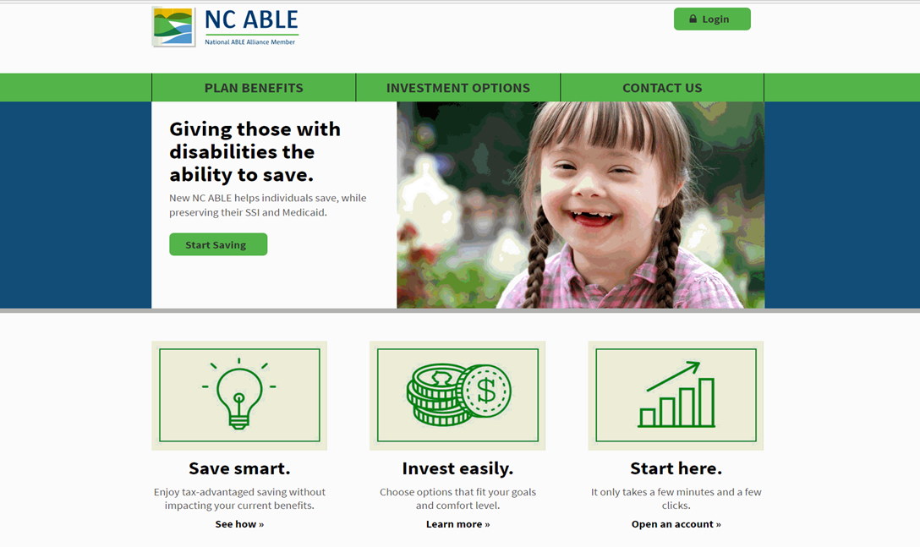

Have questions? Assistance is available Monday – Friday 8:00 – 5:00 pm ET.
Call the NC ABLE Program Customer Service Center toll-free at 888- 627-7503.
Paper enrollment is available. Visit NC.SaveWithABLE.com for more information and to download the paper enrollment form.

