Catalyst for Change Summer 2011
News of the North Carolina Council on Developmental Disabilities

Beyond Academics™ First Grads

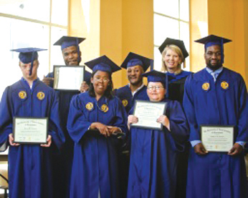
UNCG graduates, from left, Jeremy Donohue, William Gadsden, Raeshika McLean, Jason Davenport, Rebecca Clinard, Dr. Terri Shelton (Vice Chancellor of Research & Economic Development at UNCG) and DeMario Chandler.

In May, six students became the first graduates of Beyond Academics™ (BA), a four-year certificate program for individuals with intellectual and other developmental disabilities at University of North Carolina at Greensboro (UNCG).
Holly Riddle, NCCDD executive director and Steve Jordan, state director of NC Division of Mental Health, Developmental Disabilities and Substance Abuse Services, attended the celebration.
“We are so proud to see these students graduate with the skills and self-confidence to be truly engaged in their communities,” said Riddle.
In four years, BA has grown to 30 students and has openings for 18 in the fall. Executive Director Joan Johnson said that $52,000 is the average cost of support for individuals with intellectual and other developmental disabilities, but some graduates may require only $16,000 in support due to the self-advocacy, work and independent living skills learned through the program.
This registered certificate program covers three tracks and students must achieve a 2.0 GPA to graduate.
Johnson reported that all graduates will be living independently and are able to pay their rent since they have established a credit history and have a job. Most will move into a shared living arrangement. One graduate has created a micro enterprise and, at age 53, will be running a book exchange. All individuals have learned to live in neighborhoods, easily use public transportation or have a learner’s permit for their driver’s license.
The first two years of the BA program provide a general education and the second half focuses on self-direction, internships and work skills. Funding will come from a variety of sources in the future.

NC Self-Advocates Present at Atlanta
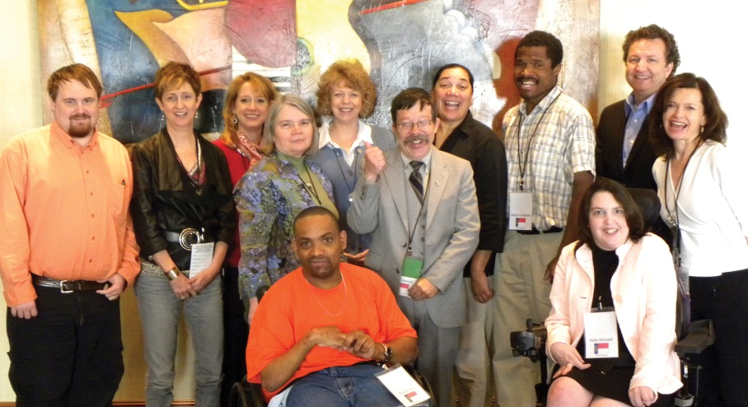
From left, standing, Rusty Bradstock, Holly Riddle, Beth Stalvey, Vicki Smith, Joan Johnson, Ed Crissman, Lalenja Harrington, William Gadsden, Steve Jordan, Deb Zuver; seated, Eric Chavis and Kelly Woodall.

A team from North Carolina headed to Atlanta in May for the Envisioning the Future ... Allies in Self-Advocacy Summit, an effort to identify steps that can further self-advocacy efforts at the state and national level.
The North Carolina delegation included several leading self-advocates, Kelly Woodall and Eric Chavez of the Association of Self-Advocates of North Carolina; NCCDD Council member Rusty Bradstock; Ed Crissman, Autism Society; and William Gadsden, a graduate of Beyond Academics™. In addition, also in attendance were the director of the NC Division of Mental Health, Developmental Disabilities, and Substance Abuse Services, Steve Jordan, NCCDD Executive Director Holly Riddle, Deborah Zuver of Carolina Institute on Developmental Disabilities; Disability Rights NC Executive Director Vicki Smith; Beth Stalvey, NCCDD policy analyst, and Joan Johnson and Lalenjua Harrington of Beyond Academics™.
“This was a call to action for self-advocates across the country. We are pleased to see the U.S. Administration on Developmental Disabilities (ADD) give self-advocates the opportunity to make their voices heard and in doing so strengthen a movement that is about community for all,” said Holly Riddle.
Other states at this regional session were Tennessee, Alabama, Florida and Mississippi. This effort to gather input on self-advocacy policy was prompted by the leadership of ADD Commissioner Sharon Lewis.

Unstoppable Advocates for People First Language
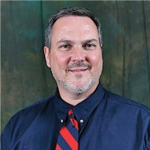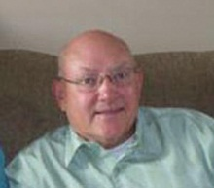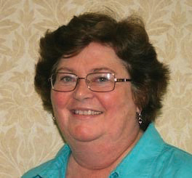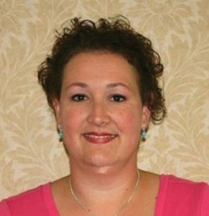
From left, Doug Hedrick, Bob West, Mary Colby and April Houston are determined to talk to all community groups about People First language.

Driven and determined to make a difference, four graduates of the NC Partners in Policymaking advocacy training program are speaking up for People First language. Armed with the booklet on respectful language, “We have not met just yet, but I am your neighbor,” they want to increase respect for individuals with disabilities by changing people’s language.
Starting with one-on-one conversations, then presenting to community groups, providing webinars and talking to the media, the group is even more focused on their target.
“I am advocating for my children and all children with disabilities,” said Mary Colby, who has woven the message into her work with the Family Service Network of Hope, as well as other community organizations.
Doug Hedrick, a father of two sons on the Autism spectrum, found himself addressing his local school board asking the district to officially adopt People First language. They agreed and Hedrick would like the same for all 115 North Carolina school districts.
Bob West was successful in getting his National Association of Aeronautical Examiners to adopt People First language into its by-laws. With President Obama’s goal of adding 100,000 individuals with disabilities to the workforce, all workplaces will need to learn respectful language.
April Houston has talked with businesses, churches, neighbors and relatives about words that hurt and how to show more respect for people with disabilities.
The group hosted a webinar about encouraging People First language on May 5 and July 12. The seminar is available on the Council’s website and on YouTube.

Leadership and Experience

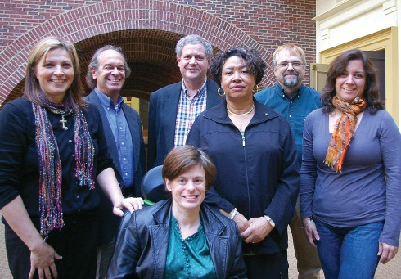
From left, standing, Deborah Wilson, Mike Whitley, Bob Rickelman, Ph.D., I. Azell Reeves, Walter Ruff III, Lourdes Fernandez; seated, Caroline “Carrie” Ambrose.

From Sylva to Charlotte to Greensboro and east to Richlands, executive committee members represent the far corners of the state as they work closely with the NCCDD staff to fulfill Council goals.
Bob Rickelman, Ph.D., of Charlotte continues as Chair, Walter Ruff III, from Sylva, is in the role of Vice Chair and Debra Wilson of Richlands will assume the responsibilities of Secretary/Treasurer. I. Azell Reeves of Greensboro chairs the Community Capacity Building committee. Mike Whitley of Charlotte chairs the Disability Systems Change committee.
In 2009, Caroline “Carrie” Ambrose of Raleigh joined the Council and was soon elected Vice Chair. She now chairs the Advocacy and Leadership committee. Ambrose has experienced an increased focus and cohesion with the group and a determination to stay close to the mission of the Council. She would like to see another self-advocate added to the executive committee.
Even with the added responsibilities and preparation required before each Council meeting, Ambrose said that she “very much enjoys the experience.”

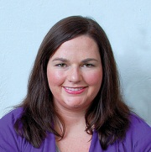
Council Staff Additions
Joining the Council staff as a program manager, Kelly Bohlander, comes with a dual Master’s degree in Public Administration and Social Work. Bohlander also served as operations manager of an adult day training facility in Tallahassee, Florida and earlier was a healthcare program analyst.

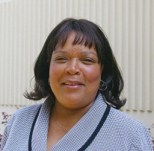
Letha Young is the new administrative assistant to the executive director. She will draw on her 11 years of experience at North Carolina State University, where she developed procedures for various conference programs. Her degree is in Arts and Administration and Professional Theater. Young’s older brother taught her about the abilities of people with disabilities and she has a passion to work with young children who need advocacy assistance.

I/DD Goes to College
Partnerships forged as programs are built
At the May Council Meeting, four NC experts on college certificate programs discussed partnerships and barriers to developing certificate programs on college campuses. The panel was preceded by a brief video, “THINK COLLEGE!”
By working with every department of University of North Carolina Greensboro, Joan Johnson explained how Beyond Academics™ (BA), a four-year college certificate program for individuals with intellectual and other developmental disabilities, created a winning initiative (see story on page 1). “We want to build a curriculum that matches the undergraduate experience,” said Johnson.
This was accomplished by matching the application forms and procedures for BA students in the areas of admissions, housing and student activities. Even with staff turnover, Terri Shelton, Ph.D., vice chancellor at UNCG and board member of BA, was part of search committees to ensure that the BA program was seen as an integral part of the University.
Beyond Academics™ uses the person-centered plan as the key driver for all aspects of the college experience.
David Westling, Ed. D. with the University Participant (UP) program at Western Carolina University, discussed the two-year program for automotive repair and healthcare. Deb Zuver reviewed information about the Leadership Education in Neurodevelopmental and Related Disabilities (LEND) program at Carolina Institute on Developmental Disabilities (University of North Carolina at Chapel Hill).
The barriers included lack of funding needed to cover housing expenses. The need for long-term stakeholder commitment and program sustainability was also discussed. Panelists agreed that partnerships with the NC Division of Vocational Rehabilitation Services, the NC Department of Public Instruction, local education agencies, the NC Division of Mental Health, Developmental Disabilities and Substance Abuse, the NC Division of Medical Assistance, the NC Council on Development al Disabilities and, of course, students, parents and teachers, led to success for these ground-breaking programs.

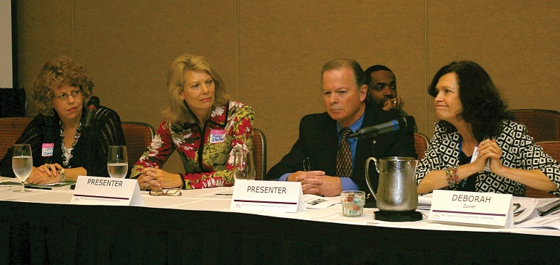
From left, Joan Johnson, Terri Shelton, Ph.D., David Westling, Ed.D., and Deb Zuver talked about the challenging partnerships and the evaluation studies that are needed as the programs graduate students with I/DD.

2011 Hefner Award
Some lead from behind and some are out in front, NCCDD would like to honor and recognize those who have made a difference to those with intellectual and developmental disabilities.
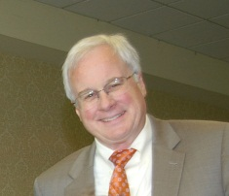
Established in 1982, the Jack B. Hefner Memorial Award has identified quality leaders in North Carolina. Nominations are now being accepted for the 2011 Hefner Award. The nomination form can be found at www.nccdd.org under the “what we do”.
Applications are due September 9. The winner will be honored at the November Council meeting.

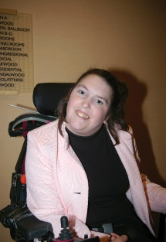
Kelly Woodall New ASANC Director
Kelly Woodall has become the executive director of the Association of Self-Advocates of North Carolina and she brings new energy and experience to the post.
Woodall set a goal to establish stronger ties with self-advocates across the state, traveling extensively to take part in area meetings.
A native of Raleigh, Woodall is a graduate in psychology of St. Andrews Presbyterian College in Laurinburg.
A veteran advocate, she began her career as a board member of First in Families of NC in 2002. Following an internship at the NC Governor’s Association for Persons with Disabilities, Woodall served at the state’s former Protection and Advocacy Organization.

Consider Council Membership
Individuals with developmental disabilities and family members of people with I/DD are encouraged to apply to serve on the North Carolina Council on Developmental Disabilities, which is comprised of 40 members. Details and application forms can be found at www.nccdd.org under the “about us”- “council members” tabs.

Preparation of this newsletter was funded by the United States Department of Health and Human Services under provisions of Public Law 106-402. The contents do not necessarily reflect the position or policies of the US Administration on Developmental Disabilities or the North Carolina Department of Health and Human Services.
Nurturing System Change
It is often said that change is the only constant, but this is part of the very charge under which the North Carolina Council on Developmental Disabilities functions. Promoting system change is part of the mission of Councils on DD and is intended to improve the lives of people with intellectual and developmental disabilities and their families.
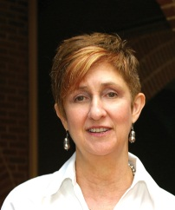
We are witnessing some changes at the federal level, with a greater emphasis being placed upon the role self-advocates have in shaping public policy and public opinion. This is an area that the NCCDD has stressed, through support for the Association of Self-Advocates of North Carolina (ASANC). We anticipate that ASANC will take a more active role in advocacy and policy development under its new executive director, Kelly Woodall (see pg. 3).
It is fitting, in this period of change, that the NCCDD is in the final stages of its five-year plan process. With the benefit of the Council members’ leadership; an in-depth study on the part of staff and consultants; and the views of the people we serve through an opinion survey, a new five-year plan has been developed. The full Council adopted the plan at its August meeting.
The Council also seeks to give new focus to increasing educational opportunities for young people with I/DD and to strengthening transition programs. Our May panel on higher education activities highlighted the issue and suggested future courses of action. It was my great pleasure to speak at the graduation ceremony for Beyond AcademicsTM at UNCG, a program supported by NCCDD that has grown in the number of students served and from a two-year to four-year program. Congratulations to all!
Much remains to be done and the NCCDD will continue to work hard on these important issues.
Sincerely,

Holly Riddle, J.D., M.Ed.
Executive Director, NCCDD

Annual Report
The new annual report has been printed and placed online. For your copy, please call the Council or visit www.nccdd.org.
Also visit NCDDC on Facebook for the latest updates on Council activities.

North Carolina Council on Developmental Disabilities
Note new address:
3125 Poplarwood Court, Suite 200
Raleigh, NC 27604
919-420-7901
www.nccdd.org
If you would like a name to be added or removed from this mailing list, contact Cora Gibson at (919) 420-7901, or e-mail info@nccdd.org

