Directions to NCCDD Conference Room
McBryde Building Access Point B
1101 Flora Lane
Raleigh, NC 27603

Access Point B
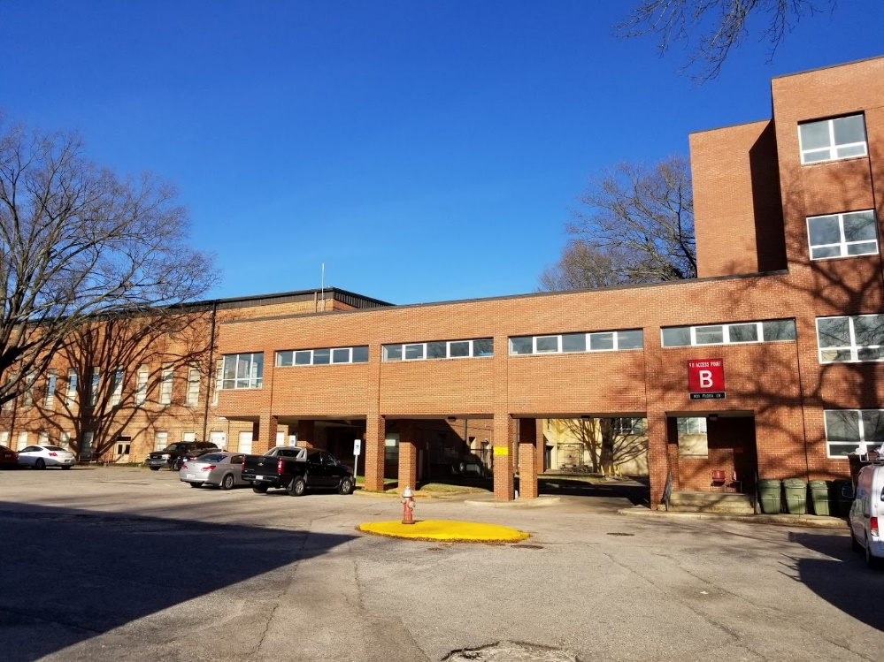

Parking Lots Outside of Access Point B
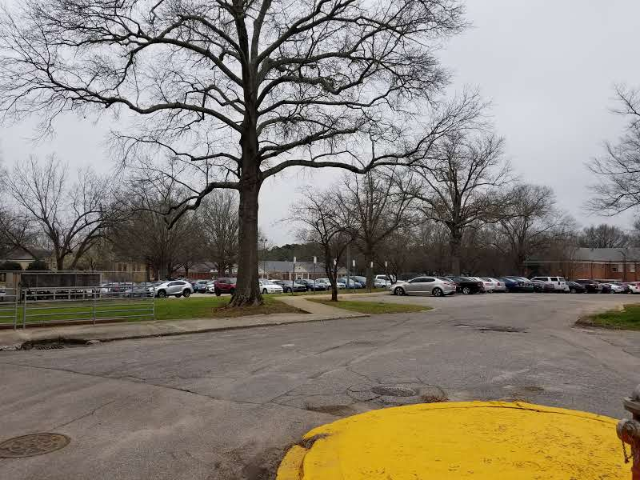
Accessible Parking for Access Point B
(Drive under the brick columns in the first photo on Page 1 to access this lot.)
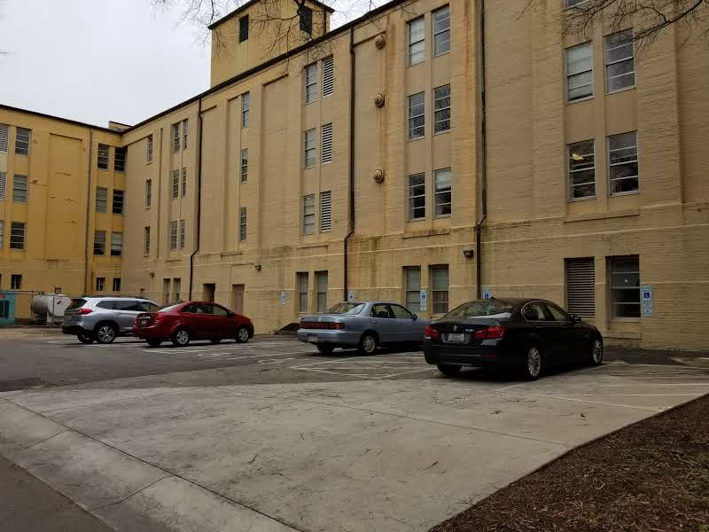

Conference Room View from Access Point B
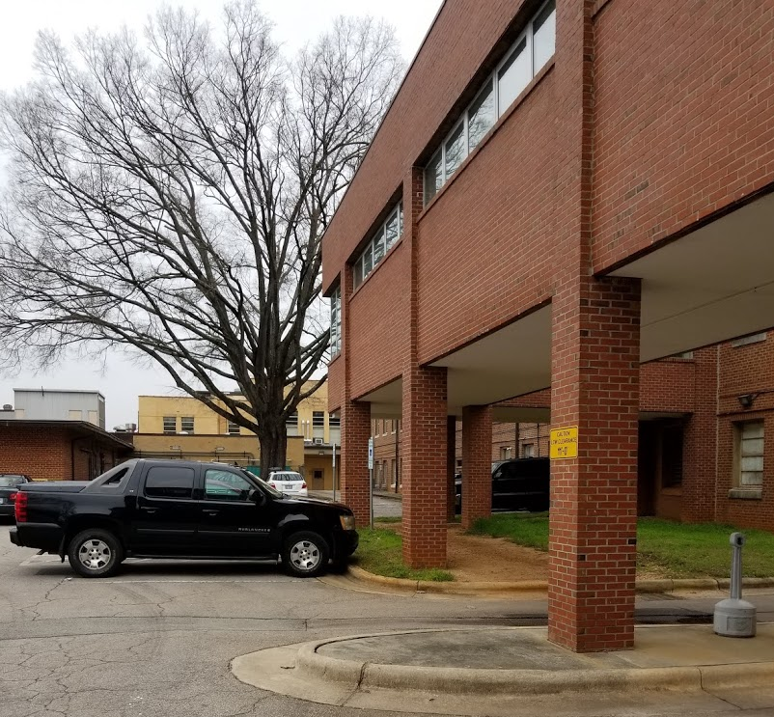

Pathway to Conference Room
(NOTE: The flowers are a photo enhancement only. This pathway is concrete with brick walls.)
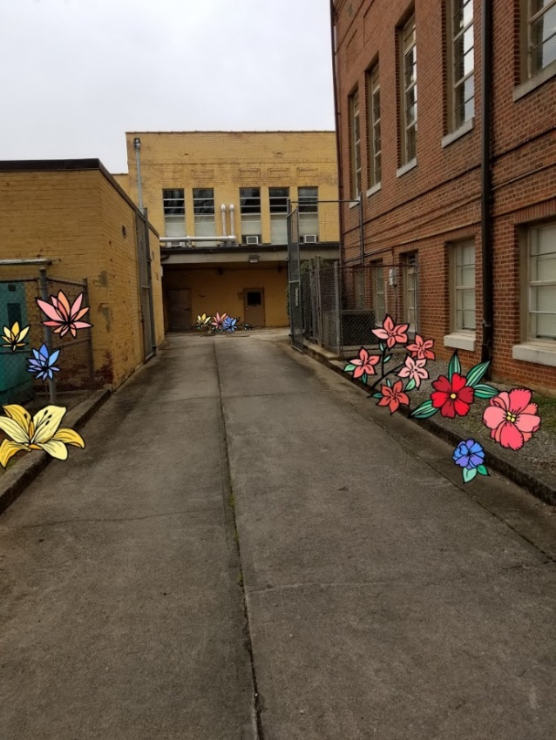

Conference Room Door
