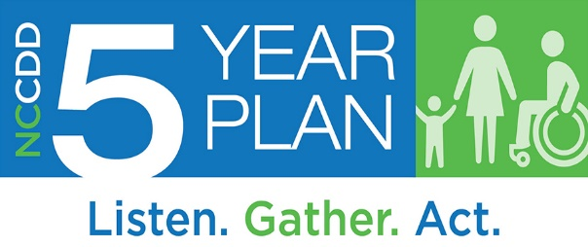
Breakout Agenda(s) [40 Minutes]

Committee Chair & NCCDD Staff as Lead(s) – Prepare to Report-Out to Council
Welcome Everyone to the Breakout Session. Provide the Following Prompt: “For these conversations, think about what the citizens of the State of North Carolina want. Think about what we heard in the listening sessions and through the surveys. What do you think, in your representative capacity, on the following questions?”
- What has been the best thing we’ve done during our current Five-Year State Plan?
- Based on the information we heard about in the surveys and listening sessions, do we need to reprioritize our focus areas? Why?
- What’s missing from the information we received in the survey responses and listening sessions, what did we not hear about that North Carolinians living with I/DD and their families need?
- Based on the survey and listening session responses, how should we change the Objectives in our current Five-Year Plan Goals for our next Five-Year State Plan?
- Based on this information, do we need to remove or change some Goals to address these needs? Why?
- Are the current Committees structured in a meaningful manner to solicit feedback and measure our progress on our Goals and Objectives?
- Do we need to change what existing committees do in 2022?
- Are we making a difference? How do you know?
- Was there anything you wanted to suggest or now think we should discuss?

