FUTURE INVESTMENT PROPOSAL 5/12/2022

$75,000 Proposal to Fund Diverse Array of Summer NC-I/DD Mini Grants to Increase Community Living
Initiative Goals and Timeline

Request for Authority to Draft RFA May 2022
Anticipated Approval of Draft RFA May 2022
Anticipated Release of RFA May 2022
Anticipated Contractor Approval June 2022
Anticipated Start Date June 2022
End Date September 9, 2022
___________________________________________________________________________________
This proposal is for The North Carolina Council on Developmental Disabilities (NCCDD) to fund a diverse array of short-term Summer NC-I/DD Mini-Grants to support system change activities or build capacity to enable individuals with intellectual and developmental disabilities to live full and meaningful lives in the community. The amount of any one Sumer NC-I/DD Mini-Grant would not exceed $25,000. NCCDD would provide funding in an amount up to $75,000 to fund the Summer NC-I/DD Mini-Grants. These grants would be paid for by FY 2021 funds and, if necessary, a limited amount of FY 2022 funds.
Summer Mini-Grants could support the following types of activities:
- The development and production of online trainings,
- Self-advocacy discussions or events,
- Development of Written Materials
- Back to School Exceptional Children Trainings
- Awareness and education events,
- Short-term research and white papers with concrete recommendations,
- Accommodations for trainings or conferences for individuals with I/DD,
- Translation of education materials,
- Development of plain language materials,
- Provide ADA training to help state government entities and private businesses on their obligations under the ADA to people with I/DD and ways to make their programs, facilities, and services accessible to people with disabilities,
- Provide landlord education programs to educate landlords on the needs of tenants with disabilities.
- Convene meetings or host a conference to help developers and municipalities understand the need for and the value of providing ample affordable, accessible housing options both immediately and as they plan for the future.
- Or similar activities to the above.
Summer NC-I/DD Mini-Grants could not be used for direct services, the purchase of equipment, gift cards, lobbying, and other prohibited activities listed in more detail below.
Applicants would be able to apply for Summer NC-I/DD Mini-Grants in an amount up to $25,000. The Council anticipates that some mini-grants may be funded for as low as $3,000 and other mini-grants may be for the full $25,000. All Summer Mini-Grants must end by September 9, 2022 and funds spent by that date. Summer Mini-Grants are possible due to short-term funds available to the Council, which is why such funds would need to be expended by September 9, 2022.
Application Process
NCCDD would have a brief Request for Application period of ten (10) days seeking brief two-page proposals with explanations as to how Summer Mini-Grants would support system change activities or build capacity to enable individuals with intellectual and developmental disabilities to live full and meaningful lives in the community. Applicants would answer brief questions about how funds will be spent to support the goals of the Summer Mini-Grants. Applications would need to state whether the Mini-Grant could still accomplish a proportion of its goals if only a portion of the amount requested was awarded. For instance, if an applicant applied for $10,000 and was awarded $5,000, could it accomplish approximately 50% of the goals planned with half the money or would it need to be awarded the full amount or nothing? If not all of the funds available are used after the initial RFA, then the Council staff may utilize one additional RFA period for the remaining funds. Awards would be made by a small Ad Hoc Committee developed by NCCDD.
Please note that NCCDD funds cannot be used for:
- Direct financial aid to individuals and families.
- The purchase of gift cards for individuals.
- The purchase of technology or internet services for individuals.
- The purchase of food, beverages, groceries, or prescriptions for individuals.
- Paying an individual’s rent, mortgage, utility, credit card, medical, or other bills.
- Lobbying or legislative advocacy

The successful applicant should be prepared to do a brief two-page report on the outcomes of the activities performed, including gathering stories and photographs, videos, or other media that demonstrate how the Summer NC-I/DD Mini Grants improved a system or built capacity for individuals with I/DD in North Carolina to live full and meaningful lives in the community.
Achievements and Outcomes Expected

- More individuals with I/DD will be able to access their communities.
- More individuals with I/DD will have an affordable, accessible home in the community.
Expected System Change as Result

Cost and Time: Recommendation and Justification
- More individuals with I/DD will be fully included, respected, valued, and supported in their communities.
- More individuals with I/DD will live in a home of their choice in the community with the supports they need.

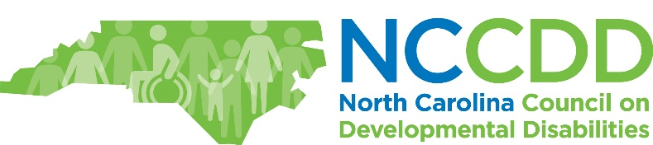

Community Living Committee

