FUTURE INVESTMENT PROPOSAL 5/12/2022

North Carolina Inclusive Postsecondary Education Alliance (IPSEA) Capacity Building Summit
Anticipated Budget: $8000
Initiative Goals and Timeline
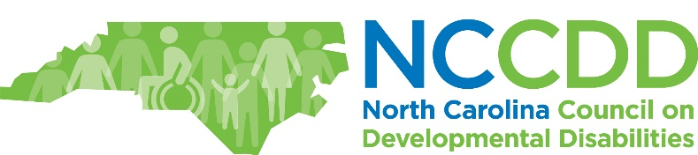

Start: 06/01/2022-9/30/2022

Conduct the NC IPSEA Capacity Building Summit to begin strategic planning around:
- Assessing gaps and system needs to support individuals with I/DD in enrolling and completing postsecondary education.
- Developing program and fiscal policies to expand and sustain postsecondary education and employment opportunities for individuals with I/DD with an increased focus on community colleges and Historically Black Colleges and Universities (HBCUs).
- Planning and implementing approaches to public awareness about postsecondary education and employment for individuals with I/DD.
- Planning and implementing joint policies and common data indicators for tracking the outcomes of people with disabilities after leaving high school.

NC IPSEA Summit will be held August 3-4, 2022 on the campus of University of NC at Greensboro.

System Gap Addressed
System Gap Addressed
This initiative will start the strategic planning/capacity building for the North Carolina Inclusive Postsecondary Education Alliance (IPSEA). IPSE Alliances have been instrumental in raising the bar and the public’s expectations regarding post-secondary for students with I/DD. This Summit will raise awareness, provide resources, and help partners including small and large institutions of higher education (with a targeted focus on Historically Black Colleges and Universities (HBCUs), state agencies, community colleges, self-advocates and families, to coordinate joint efforts to expand existing IPSE’s and support the establishment of smaller employment skills focused programs.
Background

In North Carolina there are 24 Inclusive Post-Secondary Education Programs (IPSEs). The length of these programs varies, ranging from 2 to 3 years for program completion. Out of the 24 IPSE programs in North Carolina, three are fully comprehensive programs and all three are in four-year institutions. They include Western Carolina University - University Participant Program, University of North Carolina at Greensboro - Beyond Academics, and Appalachian State University – Scholars with Diverse Abilities. All three of these programs have an excellent track record of inclusion, and are models for other institutions across the country regarding inclusive post-secondary education for students living with I/DD. Despite the availability of these four-year programs in North Carolina, that leaves most students living with I/DD limited options who may desire to attend a fully inclusive program closer to their home communities or who are unable to obtain the financial resources needed to pay the tuition costs at larger programs. Other factors such as the lack of natural supports in the areas where larger IPSE programs are located, may also be considered as reasons some students opt not to attend larger institutions.

In contrast to the larger IPE programs, there are 21 smaller IPSE programs scattered throughout North Carolina located in two-year community and technical colleges. Although the smaller programs are more widespread, they are still not in every county, and they differ in their inclusive components that comprise them. Other differences include the fact that many of these programs are solely focused on providing their students with active and meaningful days focusing more on independent living skills. Yet others, as this research will highlight, are more employment focused and intentional as it pertains to structuring programs which result in marketable career skills, partnering with community and state agencies to provide employment related supports and services, as well as engaging with their local business community to gauge what career pathways are needed for their local communities.
Description of Activities
Description of Activities

NC PSEA Summit will start networking and planning around:
- Diversity, Equity, and Inclusion in IPSE programs around the state.
- Funding opportunities
- Strategic Planning Overview from Think College
- Breakout Strategic Planning for state partners, community colleges, 4-year colleges and universities, parents, and self advocates.
Achievements and Outcomes Expected

- Increase the number of IPSE programs across the State.
- Increase the number of individuals with I/DD will be able to attend IPSE’s.
- Improve the employment rate of individuals with I/DD.
- Increase self determination and advocacy skills of individuals with I/DD.
Expected System Change as Result

Cost and Time: Recommendation and Justification
- The NC University College system, community colleges, and public schools will increase capacity for individuals with I/DD to have increased access to employment skills and career awareness through IPSE programs.

